**PRACTICAL: 3**

**IMPLEMENTING PRIVATE CLOUD WITH XEN SERVER**

Open VMware Workstation – And select Create a New Virtual Machine >> Select Typical and click Next.

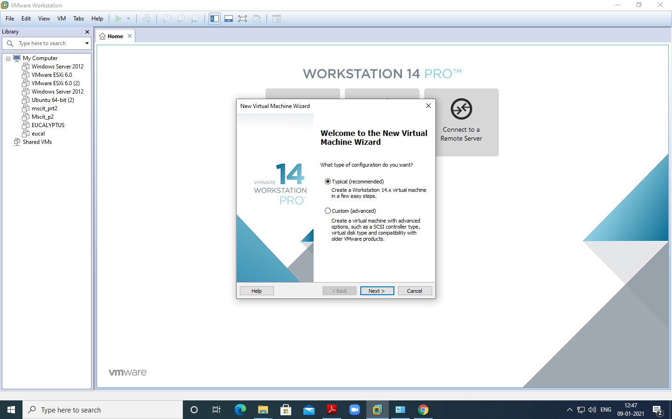

Select Installer disc_image file(ISO). Click Browse - XenServer Iso File – For Example “**E:\\ccsoftware\XenServer-6.2.0-install-cd.iso**” >> Click on next

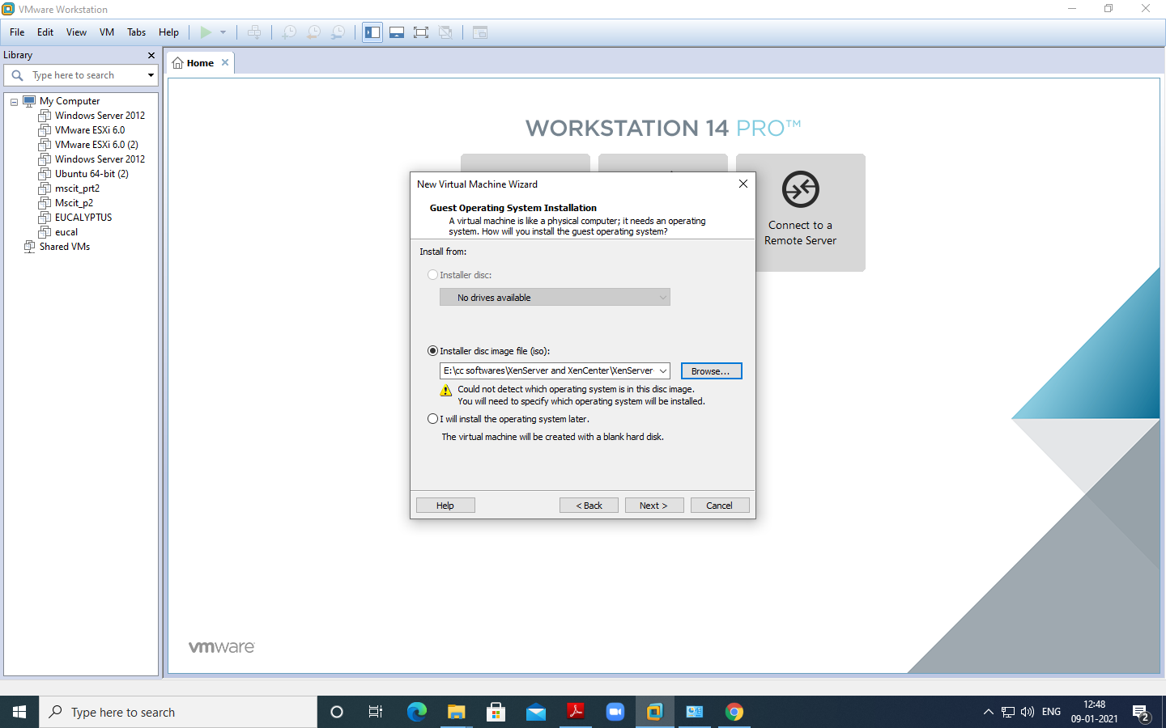

Select Guest Operating system as Linux. Version as Ubuntu. Click Next.

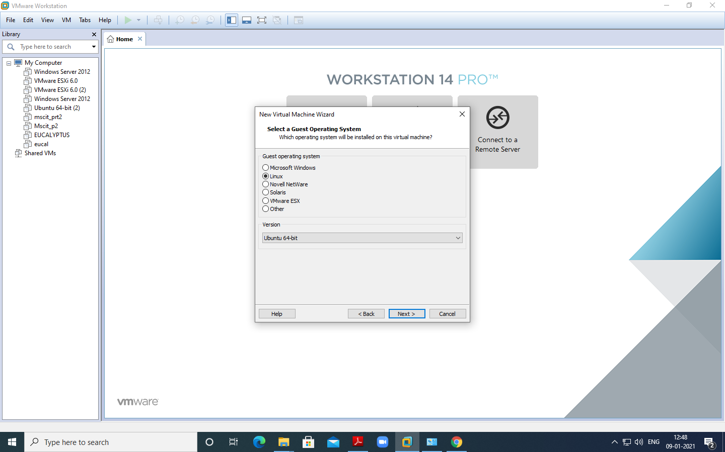

Give Virtual name – for Example “XenServerMsc1” and click on next

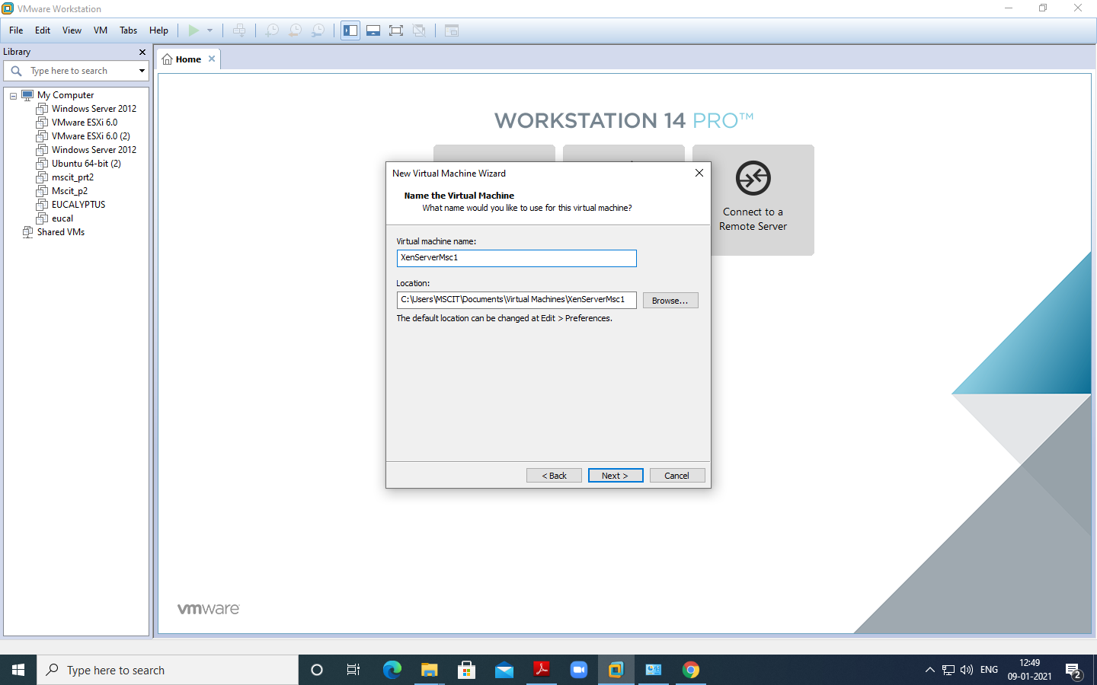

Change maximum disk size to 40 GB and check –Store virtual disk as single file.

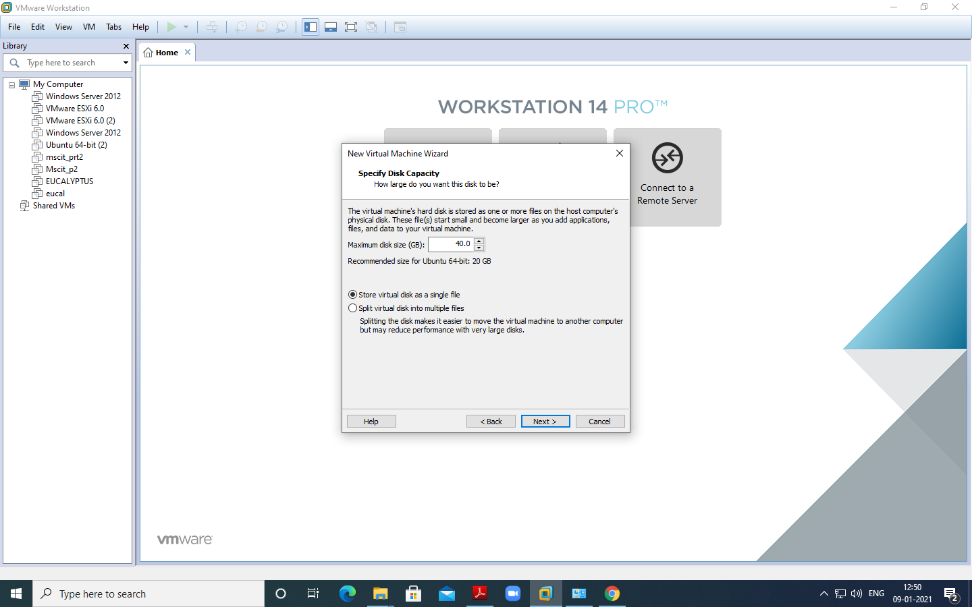

Click on **Customize Hardware option**

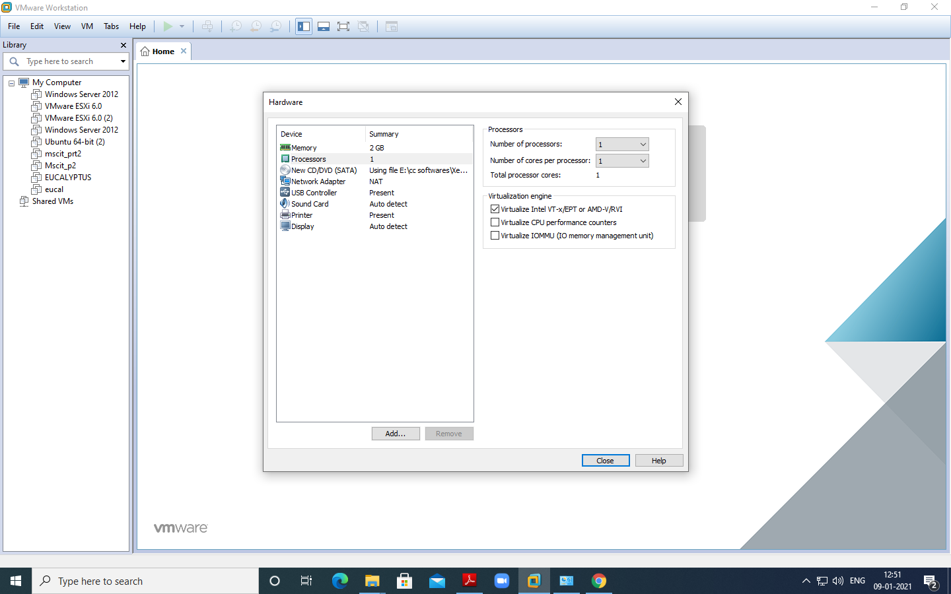

Change – Memory for this virtual machine to 2 GB and click on close

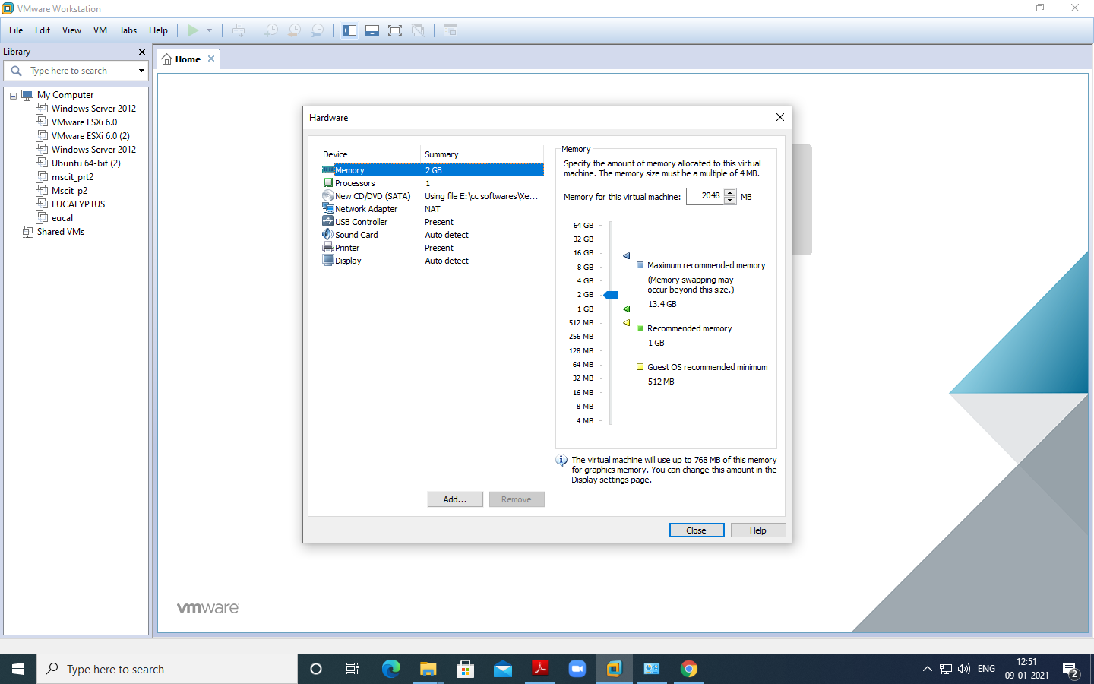

Click on Processer and select virtualize Intel VT >> Click on Finish –

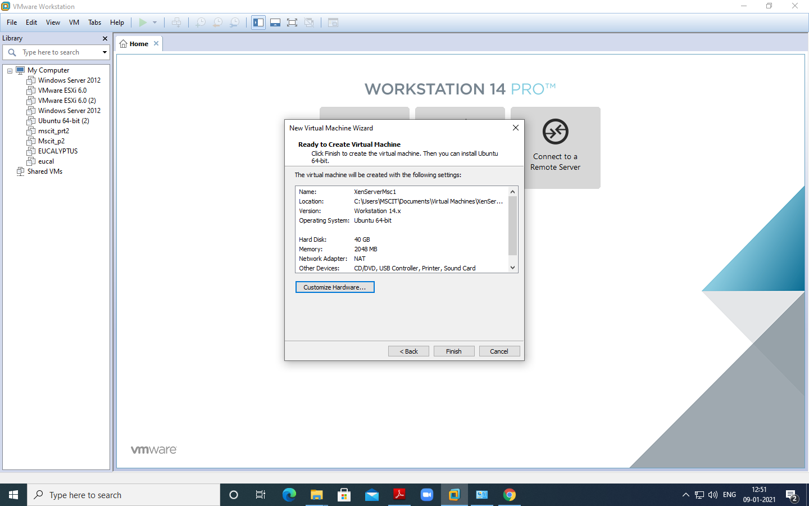

Now Power on newly created Virtual machine –

Now select US and click on OK

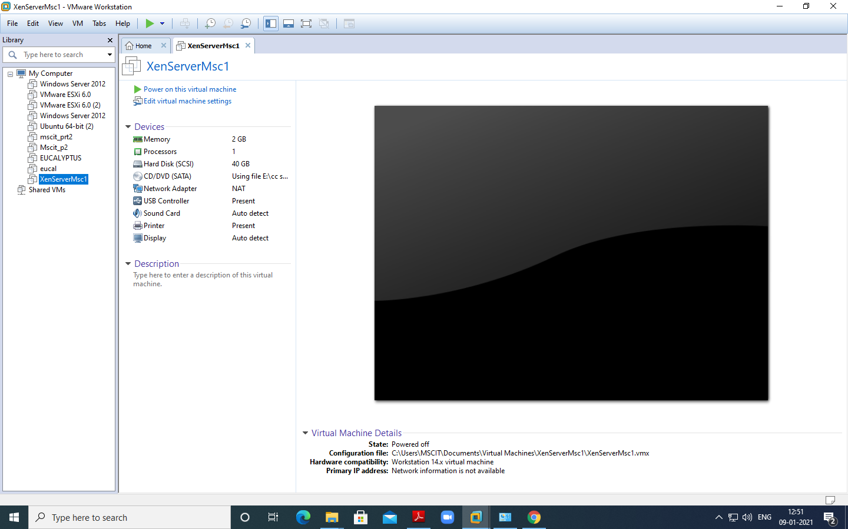

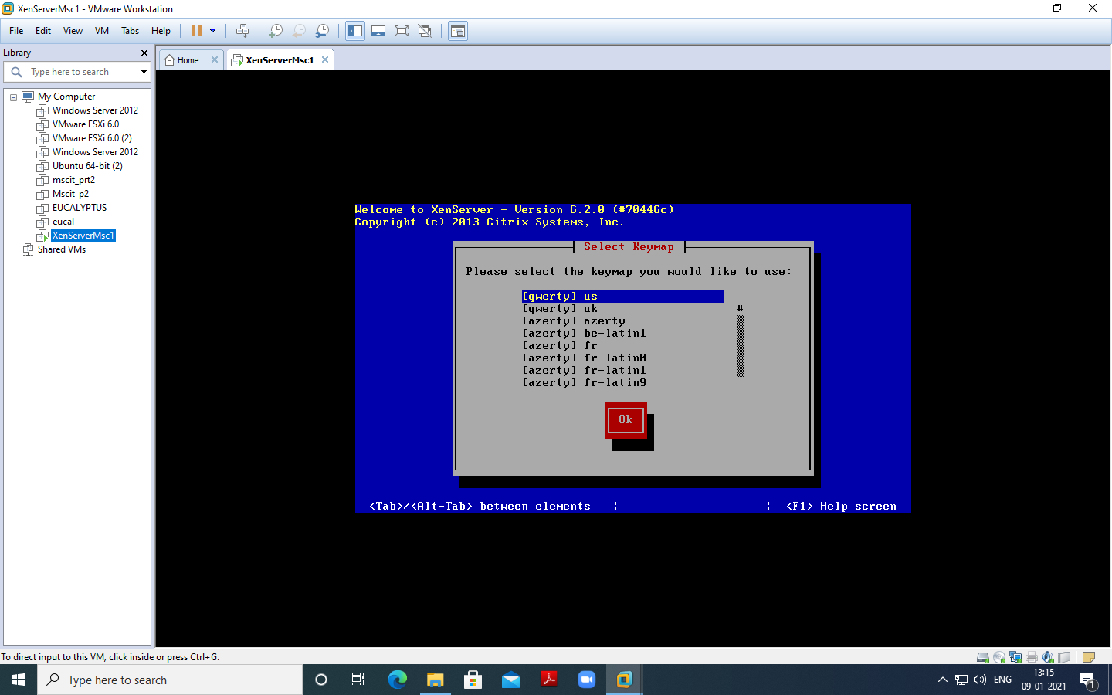

Click on OK as seen in below screenshot –

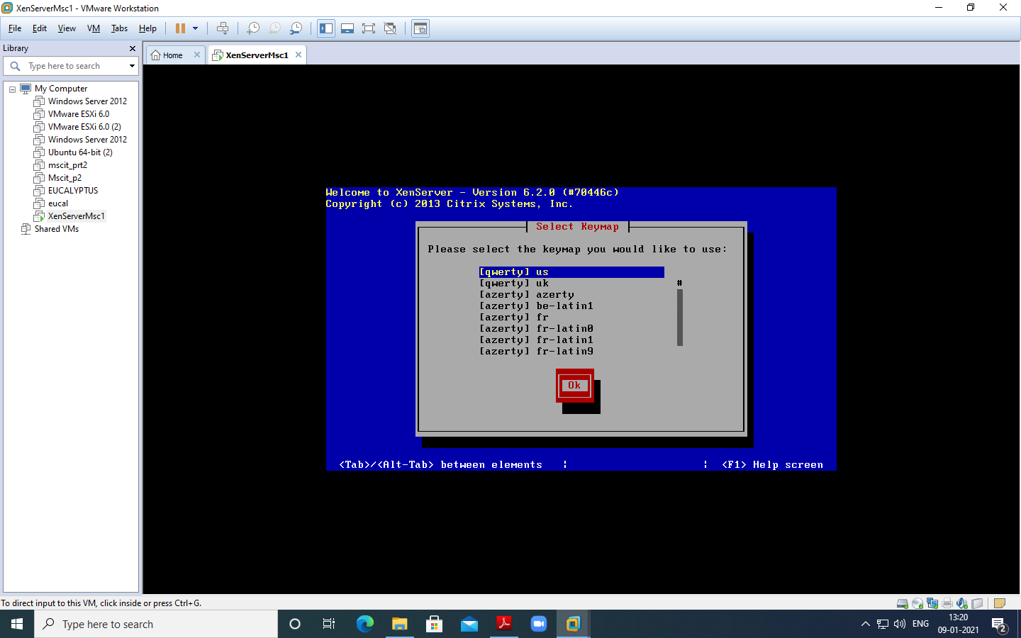

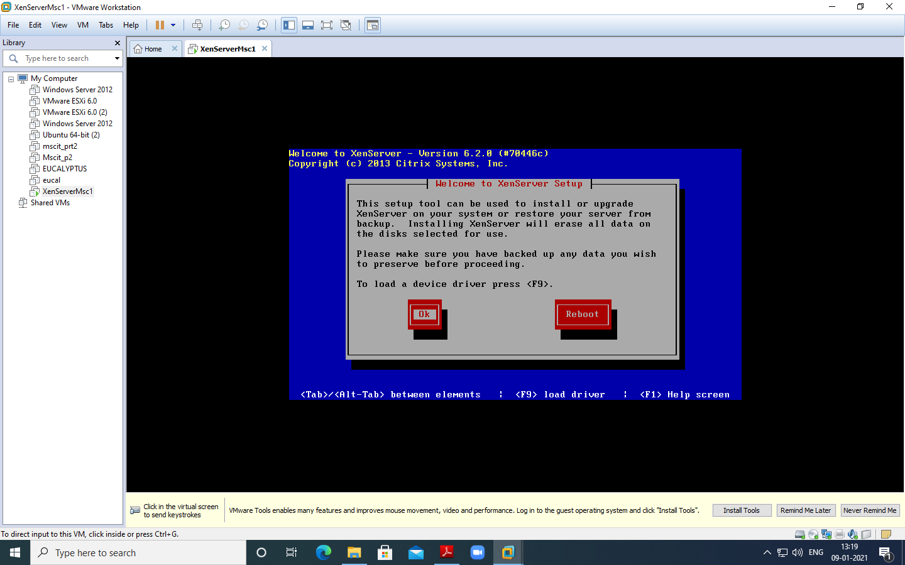

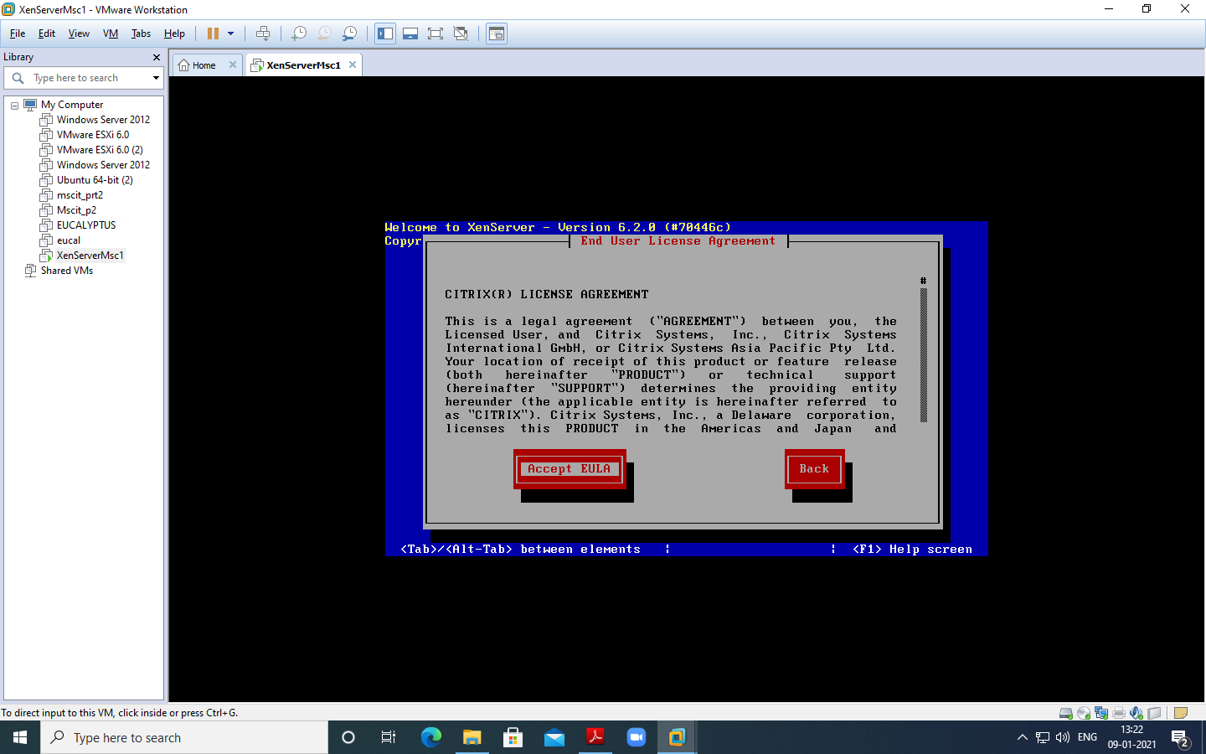

Click **ok**

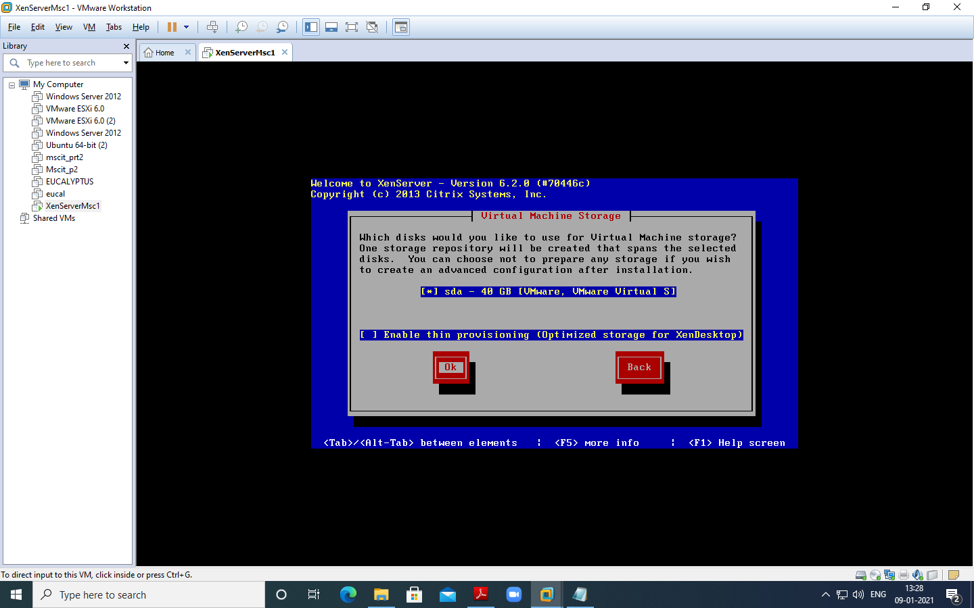

Select **Local media and ok**

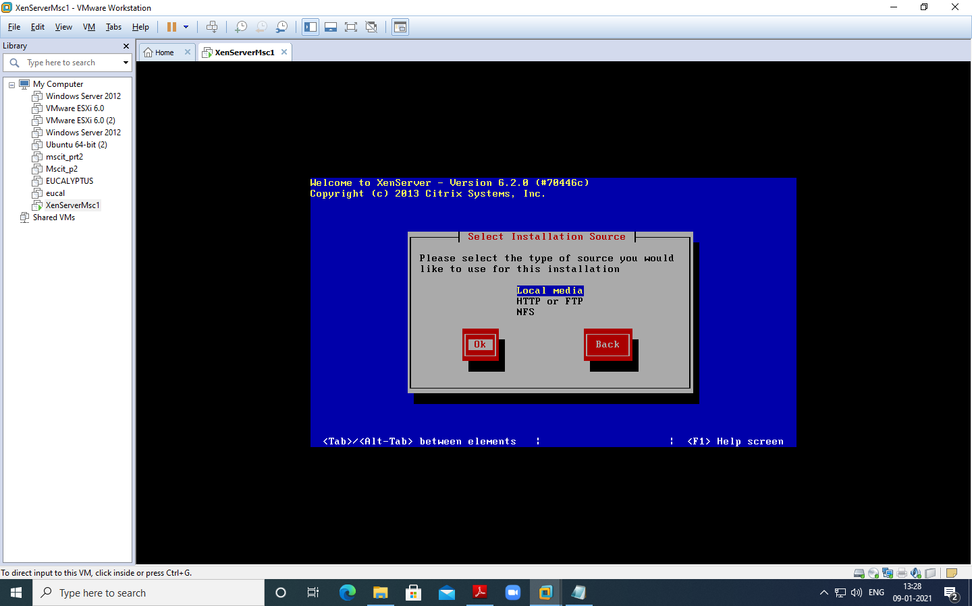

Click **No**

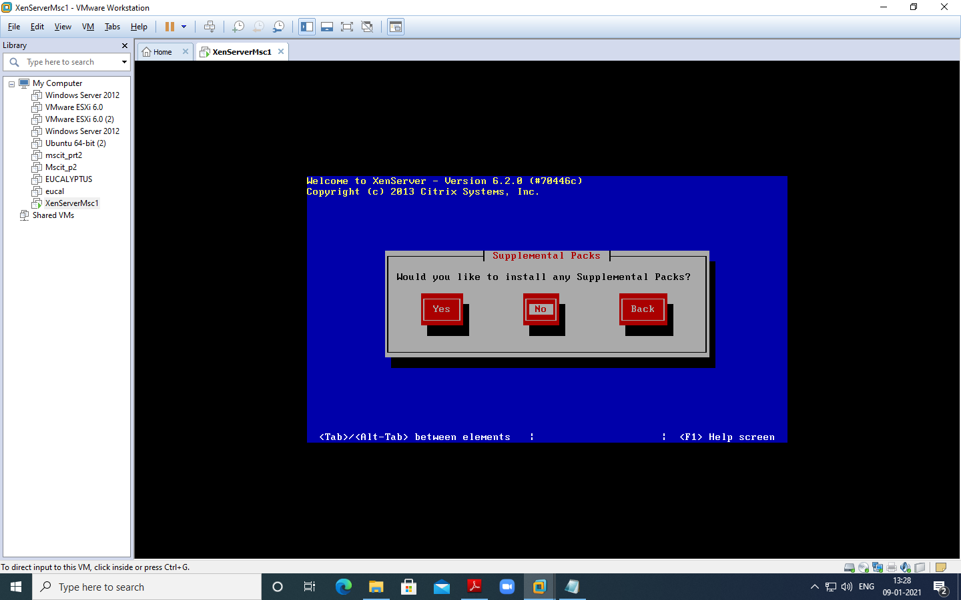

Here click **verify installation**

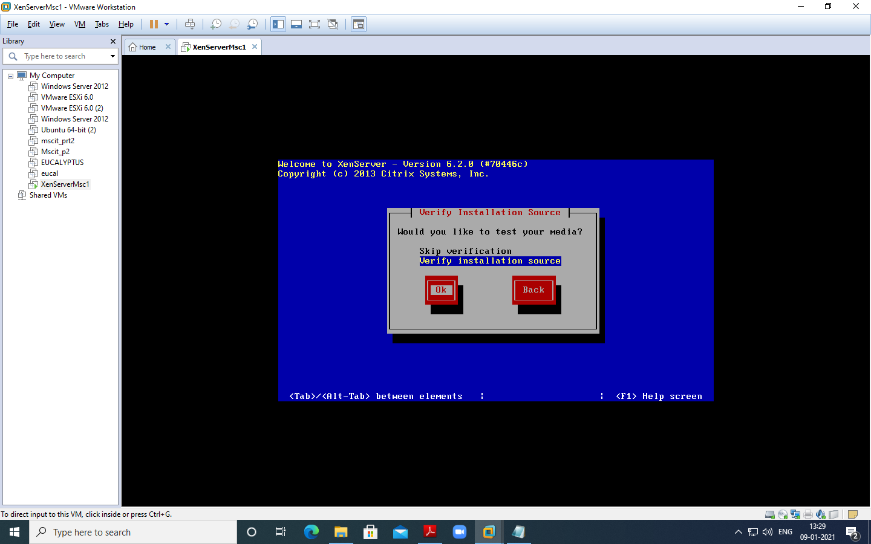

Click **ok**

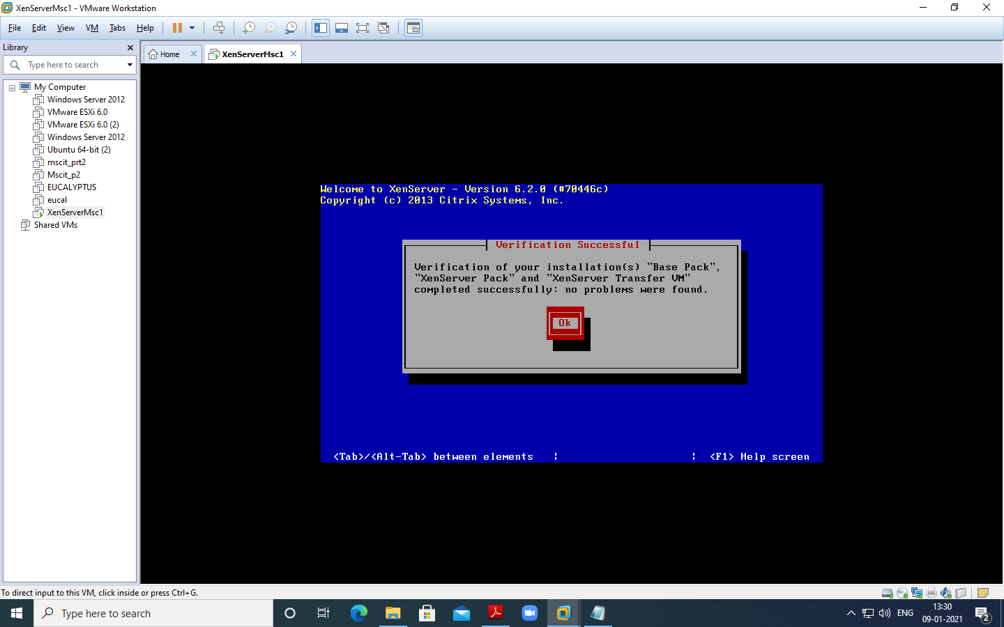

Insert password (Remember password entered) and click on Ok –

**Password:root123**

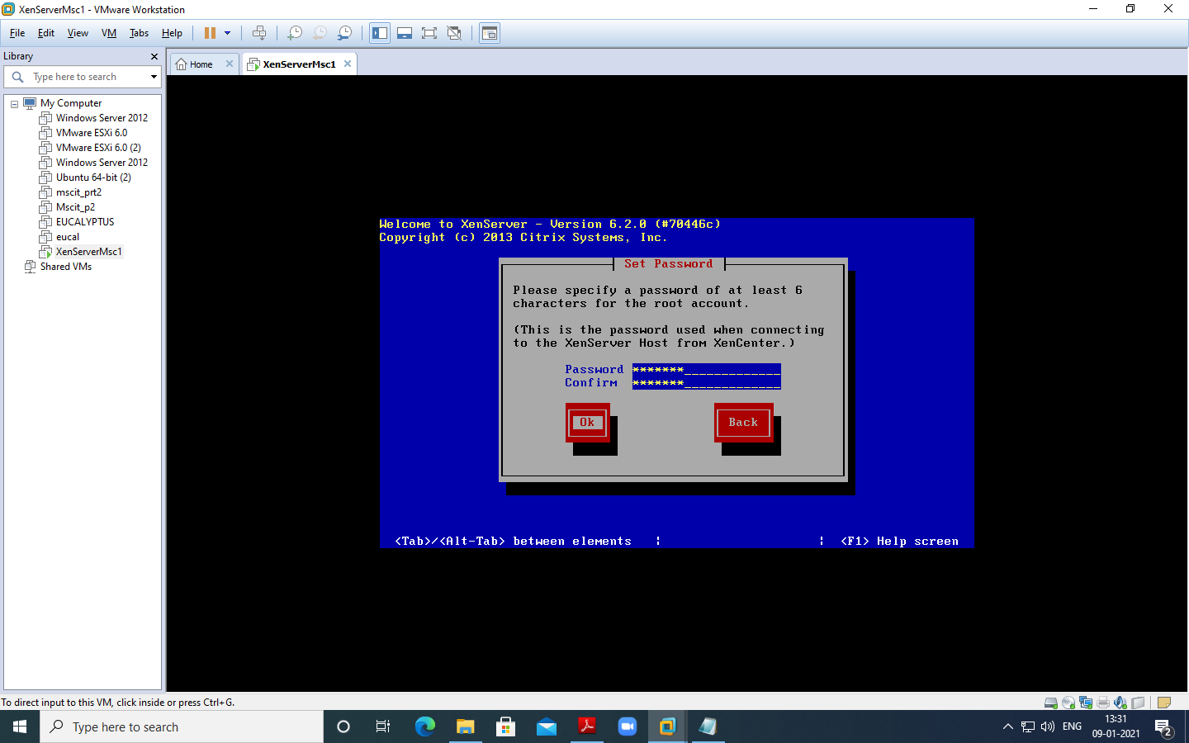

Select Automatically set via DHCP and click on OK

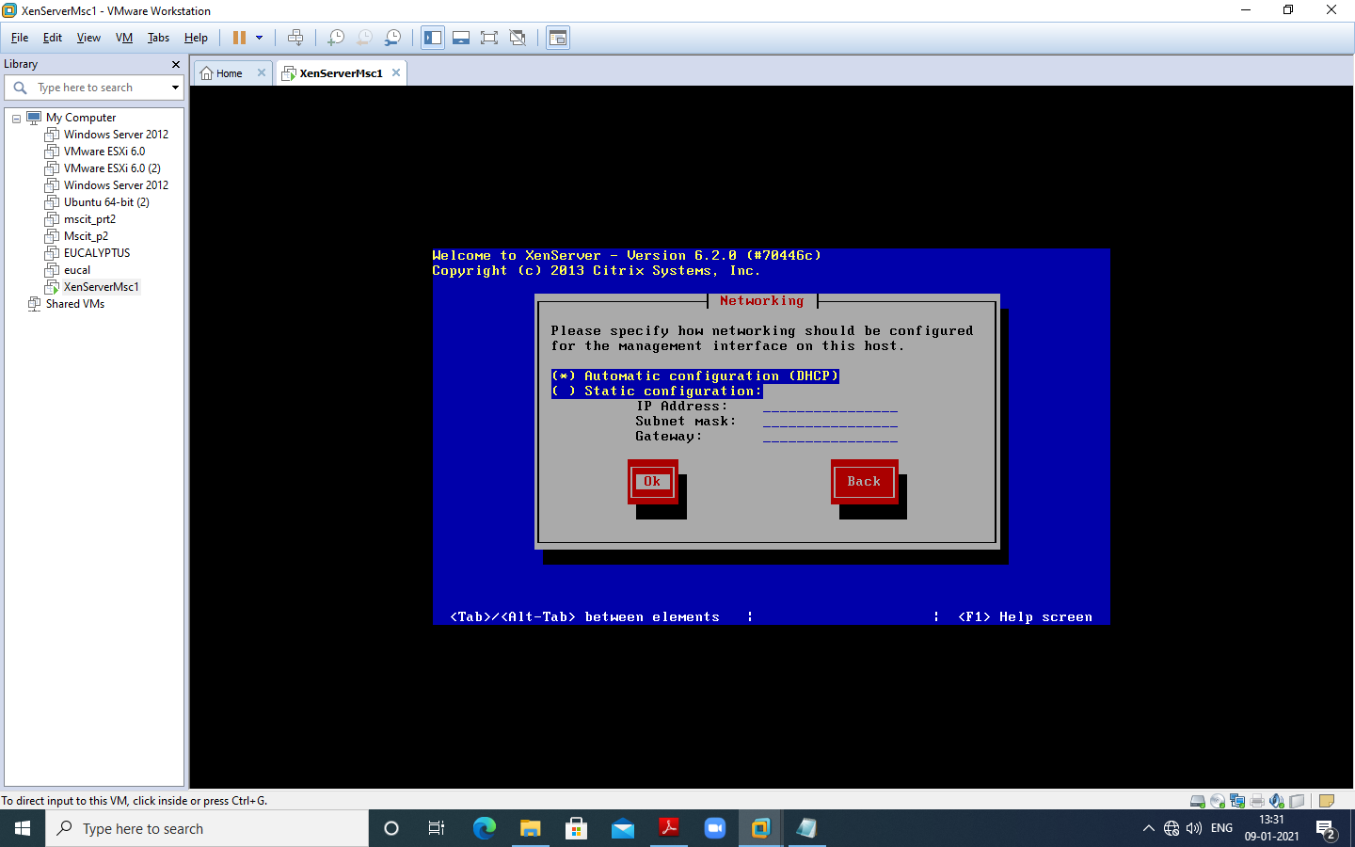

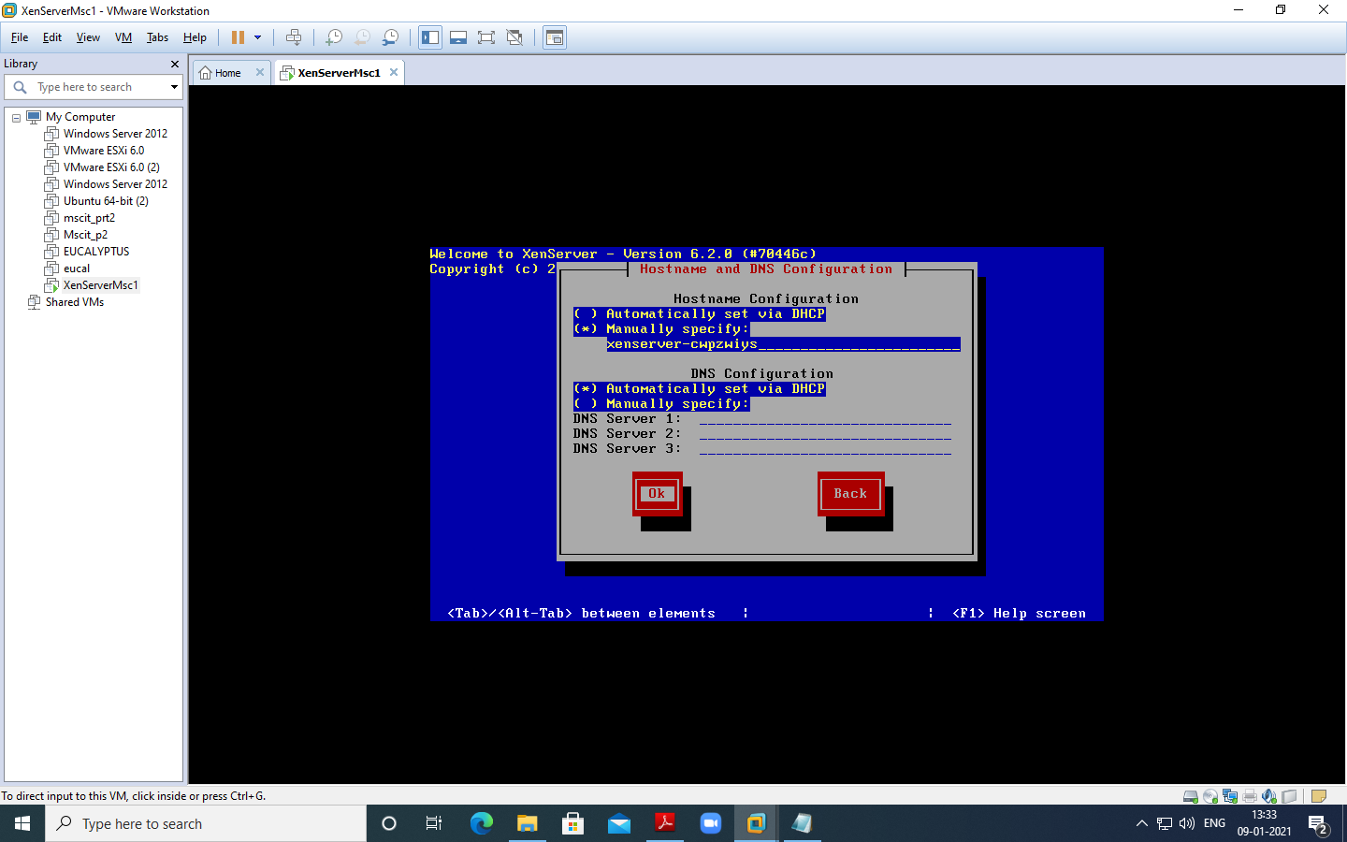

Select Asia and click on OK – >> Select **Calcutta**

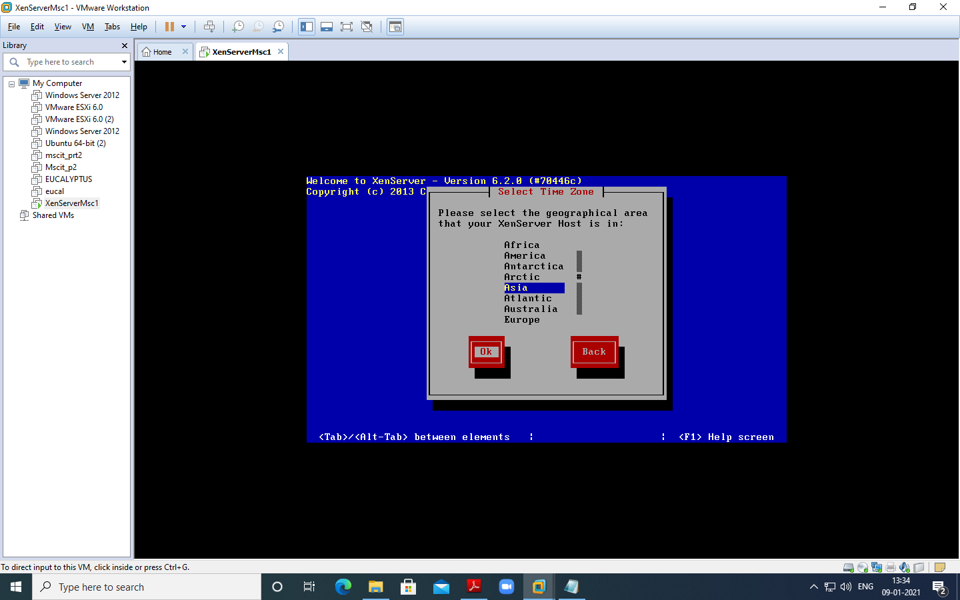

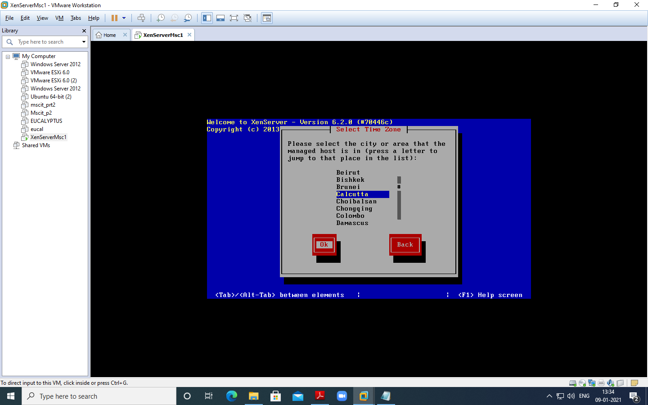

Select “Using NTP” and click on OK

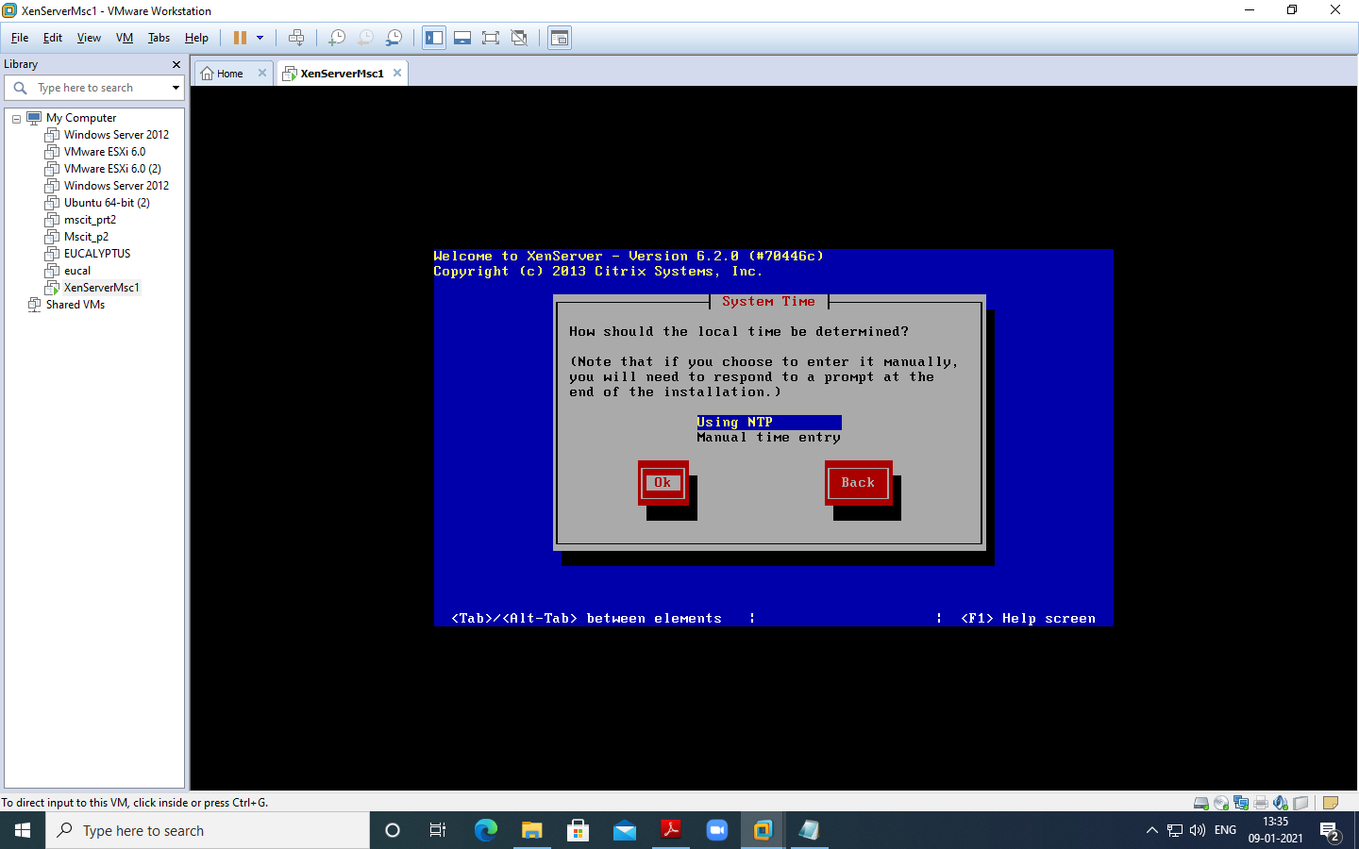

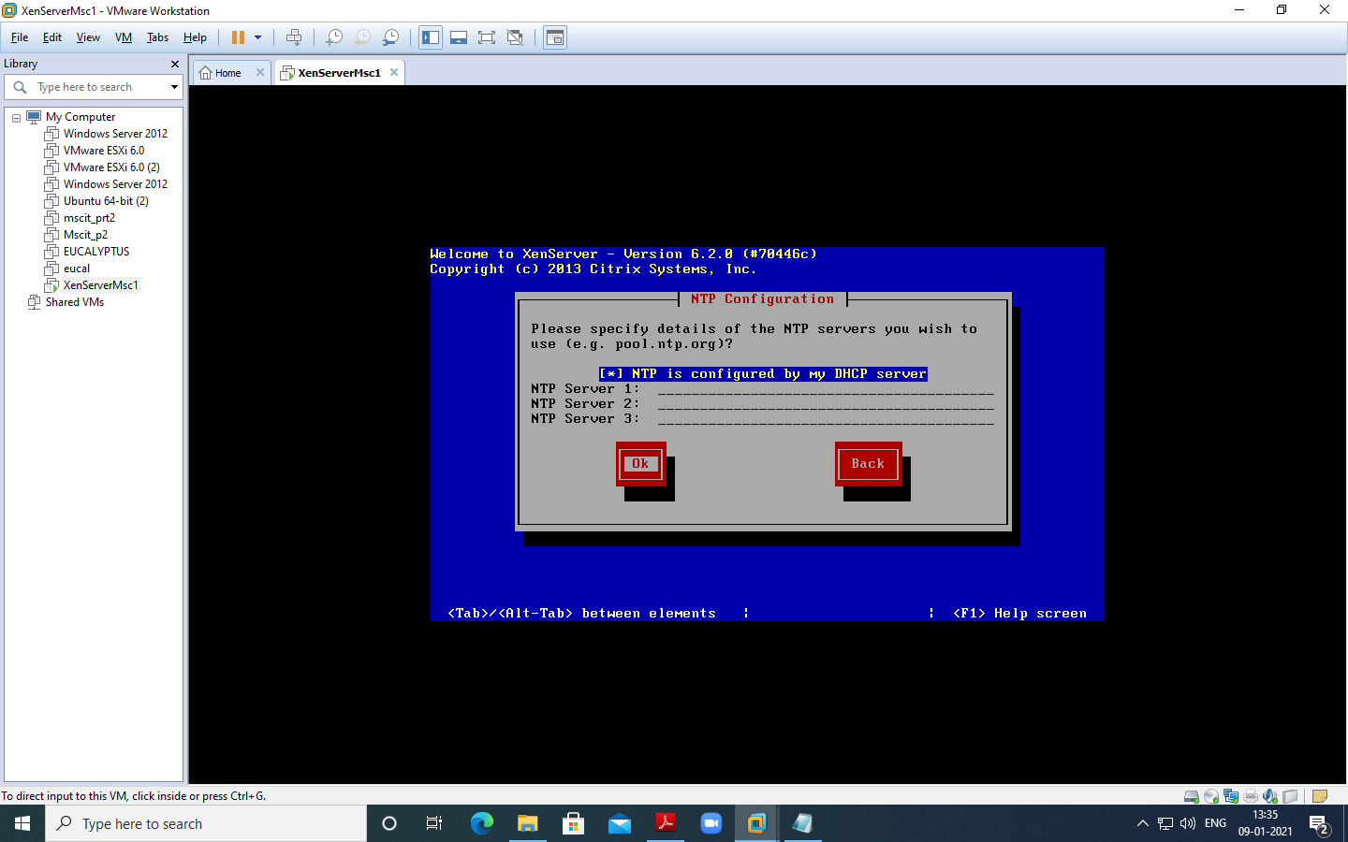

Click **Install Xen server**

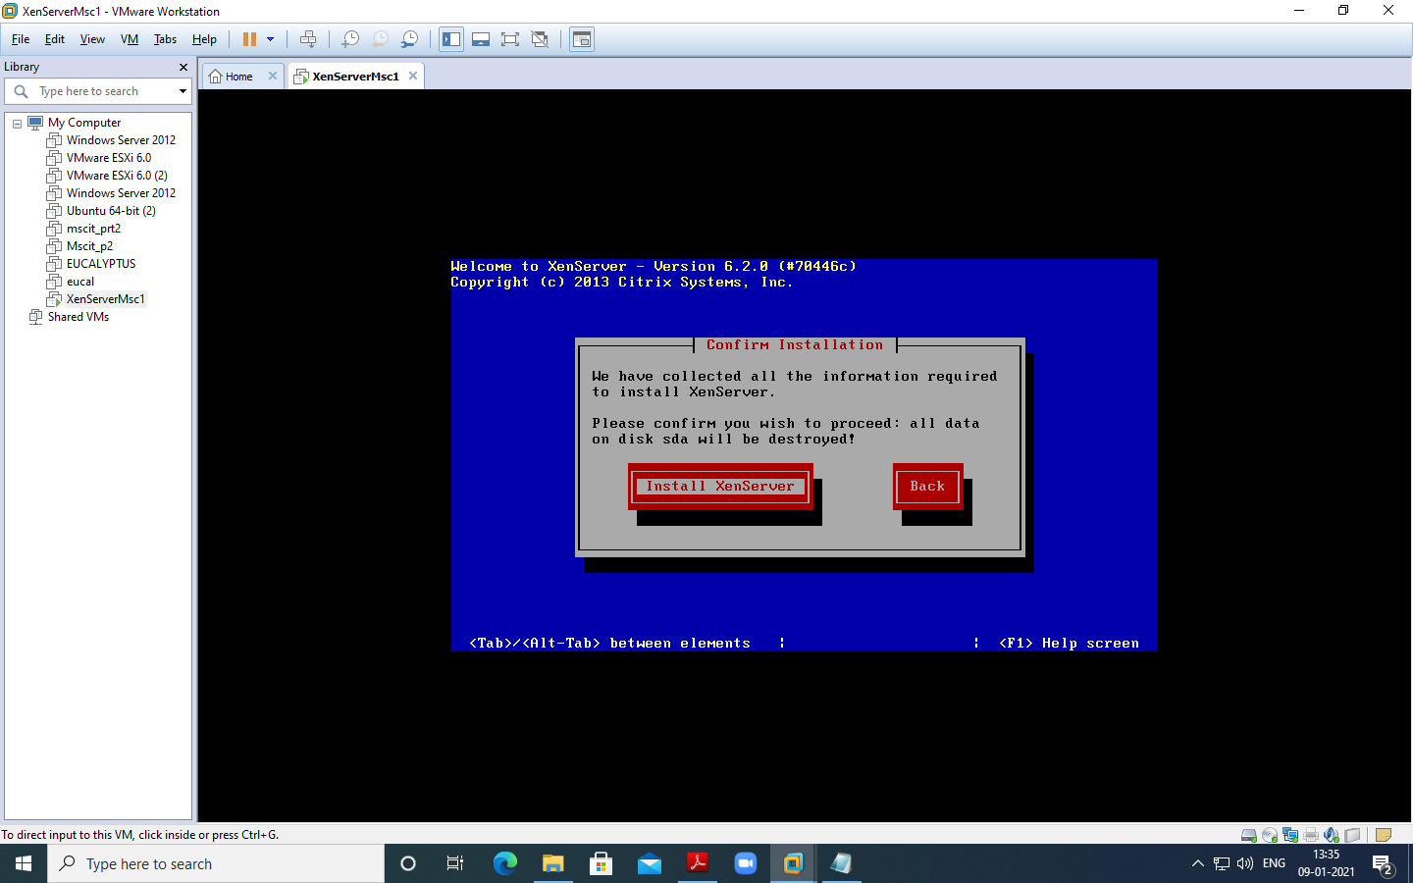

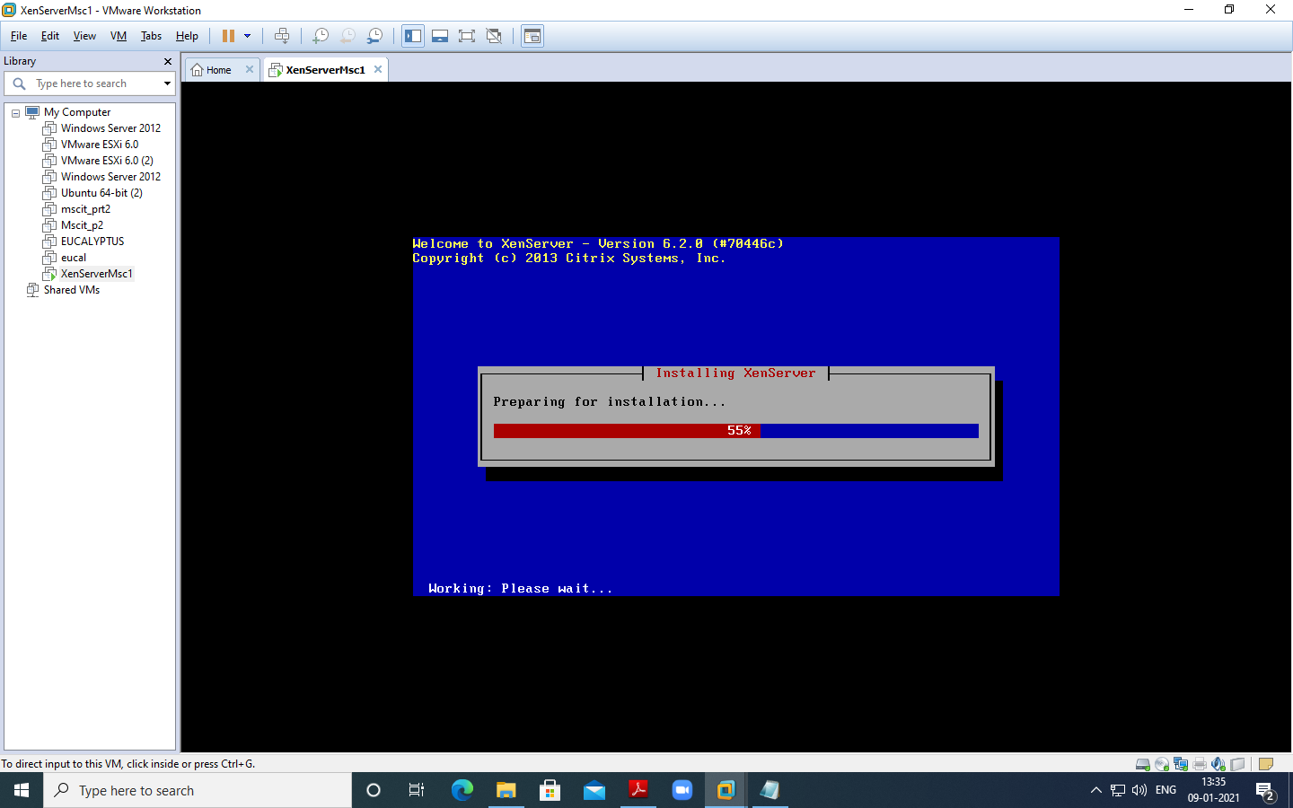

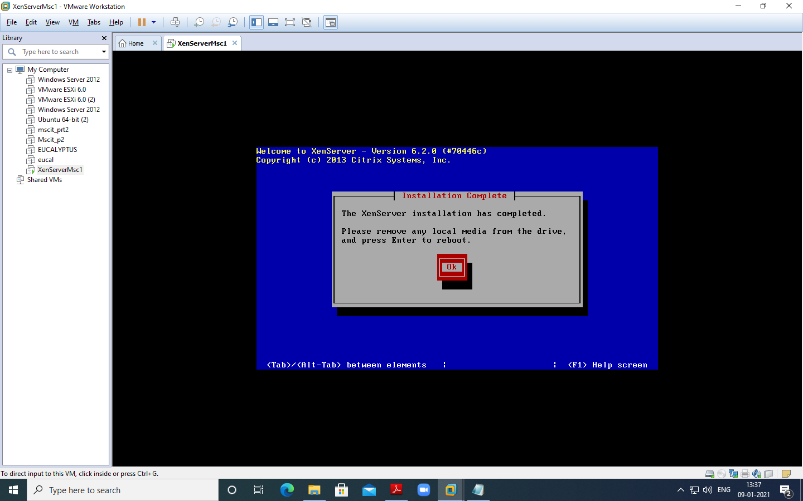

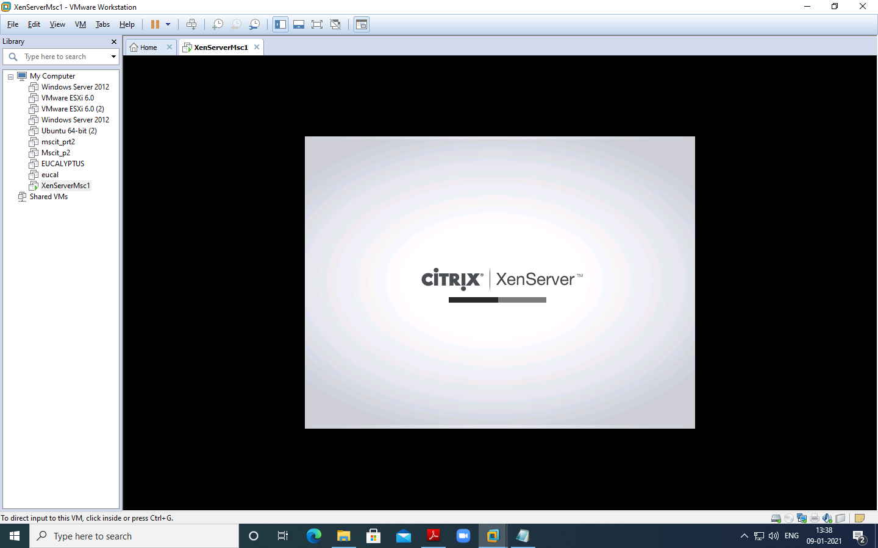

Note IP Address – “ 192.168.283.141” ping it from command prompt

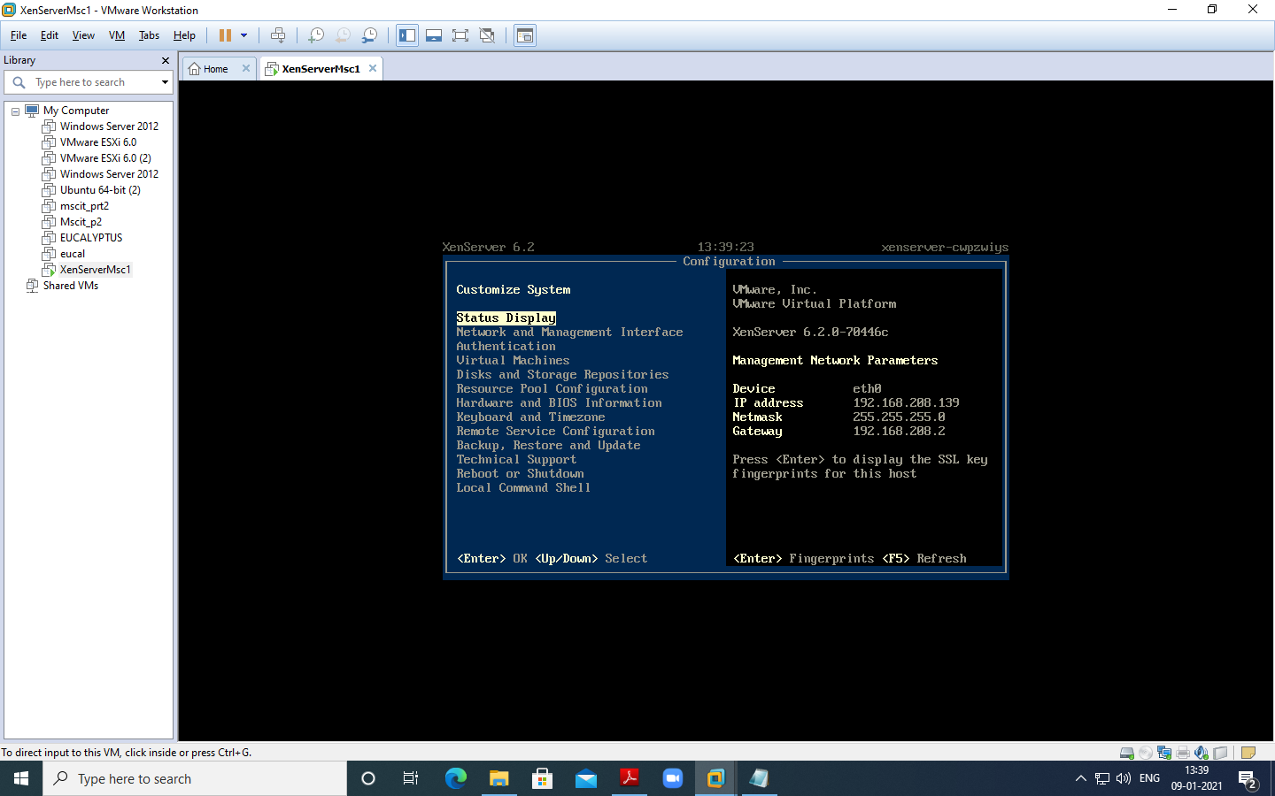

Now Install Citrix App if not installed –

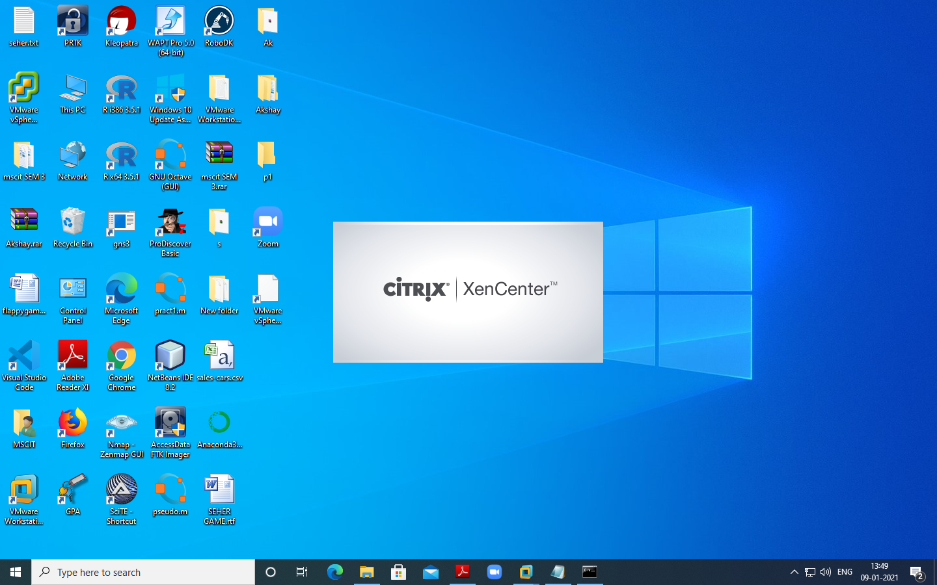

Now Open Citrix XenCenter – and Click and **Add Server**

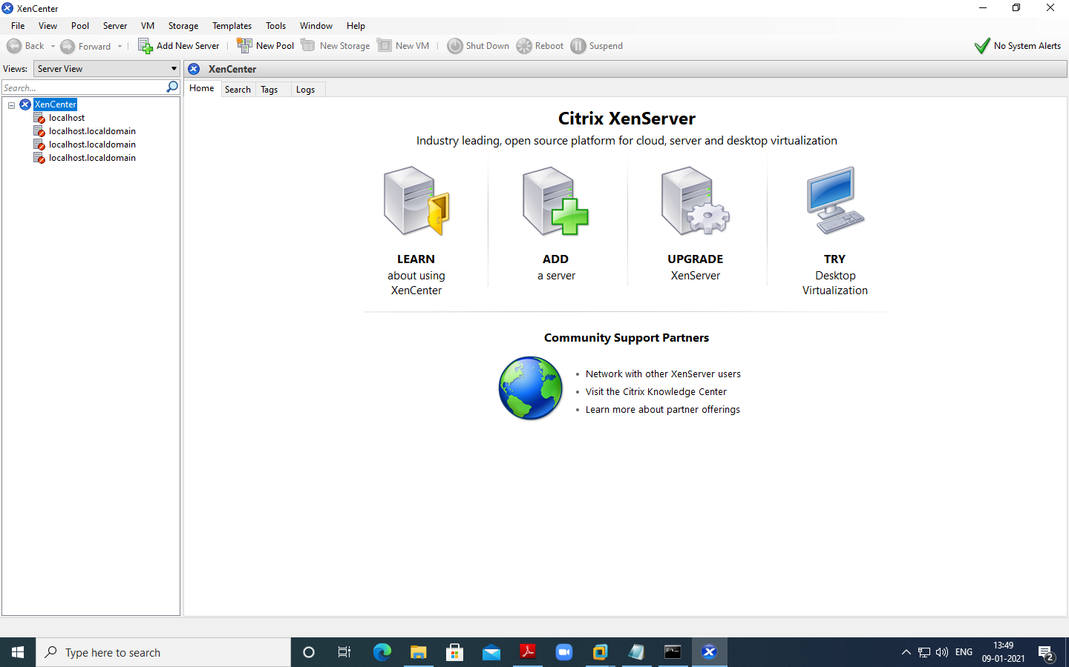

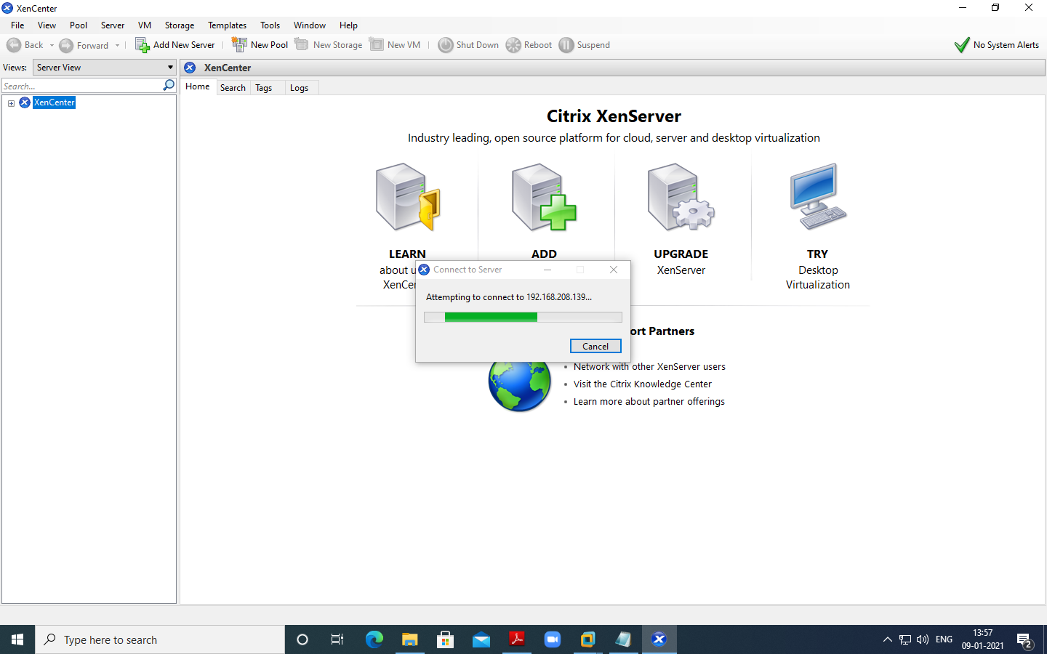

Fill IP address copied from Installation and User name as “root” and Password as “root123” which we had given during installation and Click on Add

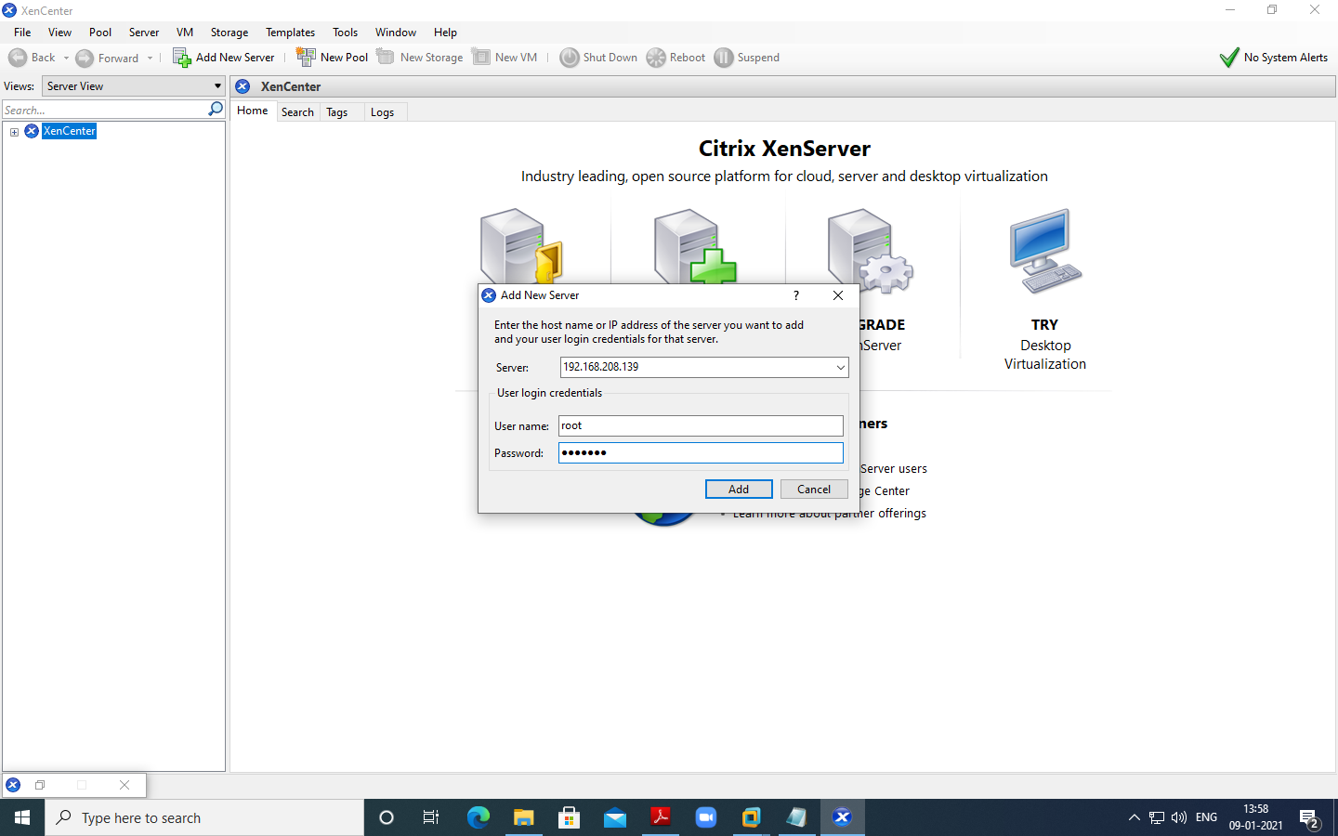

Now Click on New Storage –

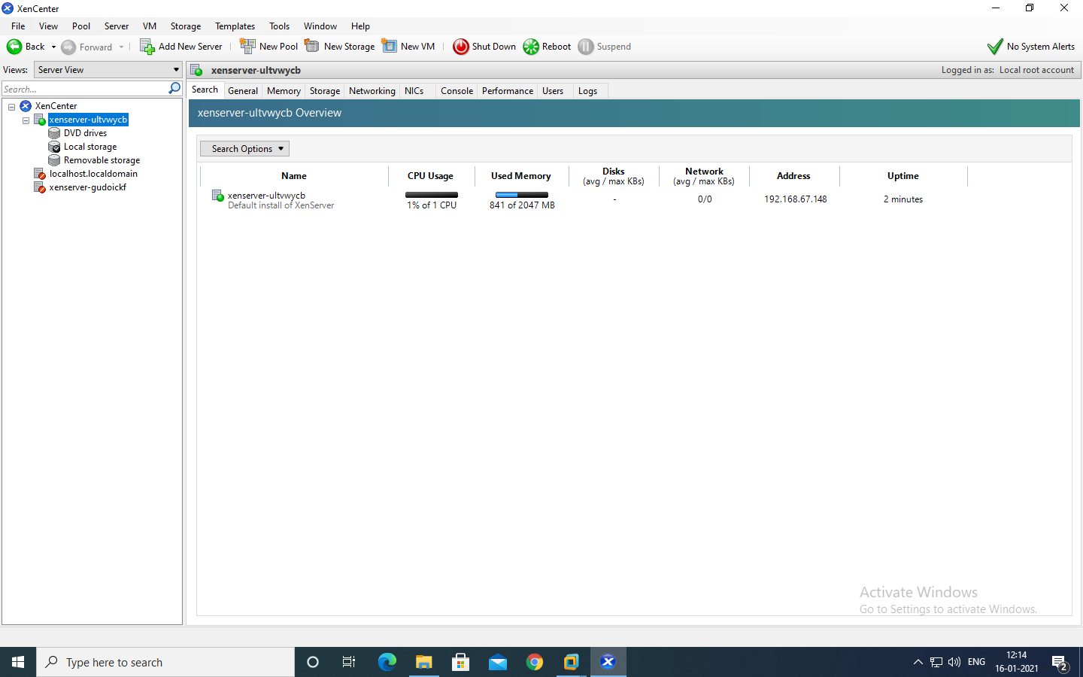

Select Window File Sharing (CIFS) and click on next –

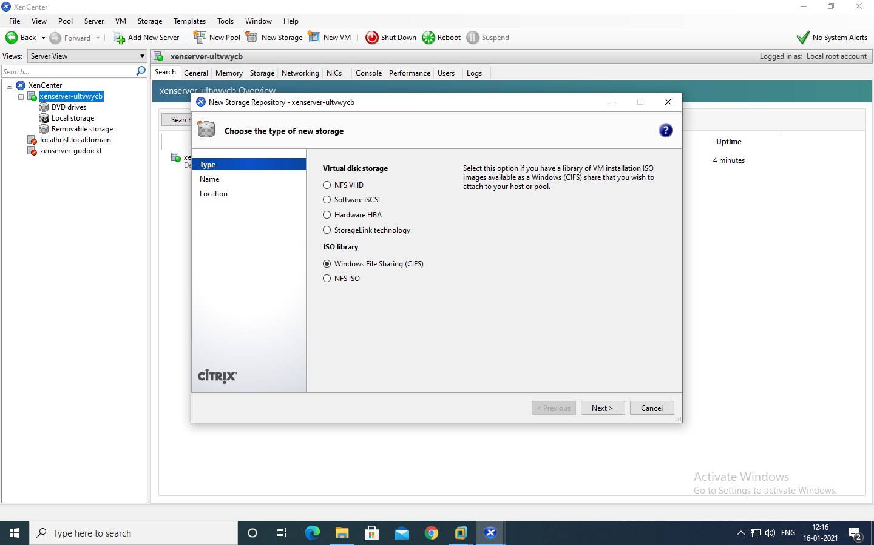

Uncheck Auto generate option Click on Next >> Provide the path of shared windows XP image and enter local pc credential, click on Finish.

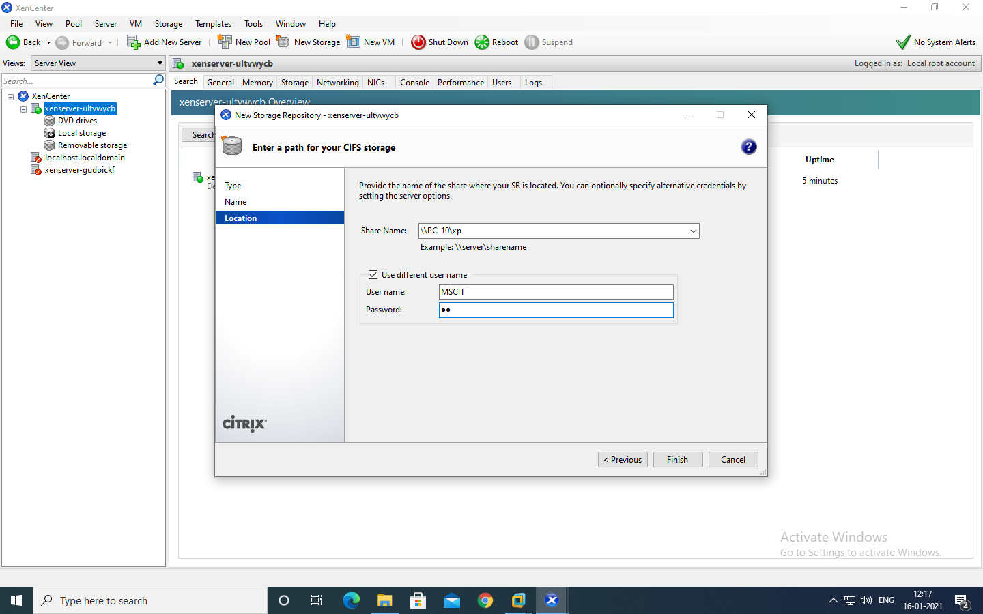

Click on New VM – and Windows XP SP3

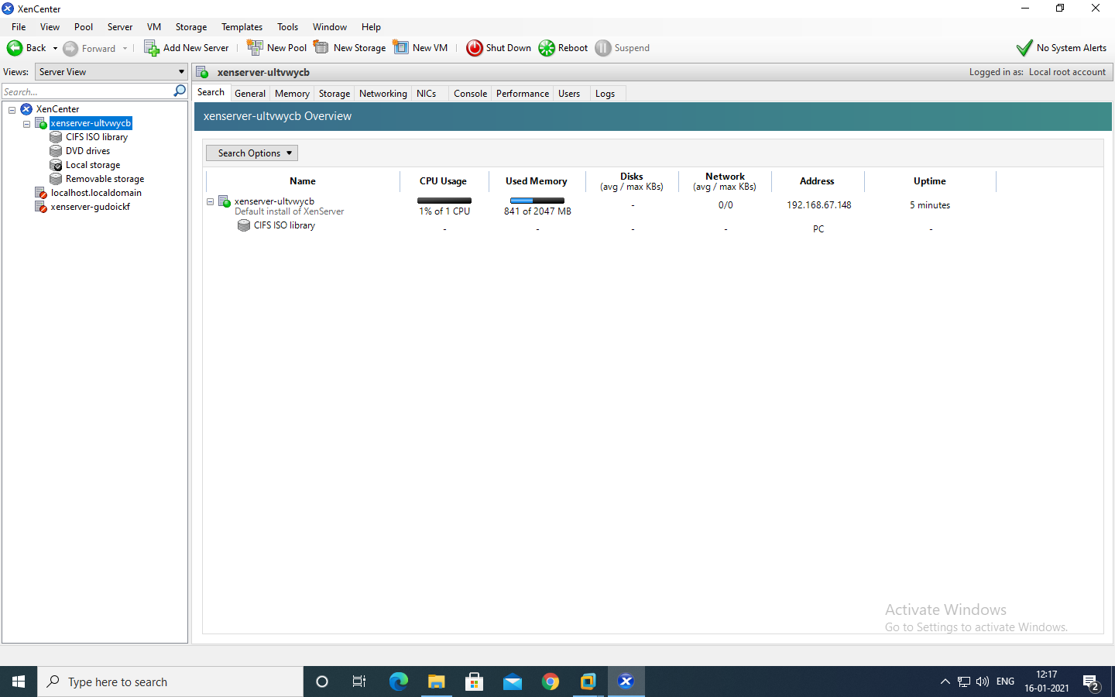

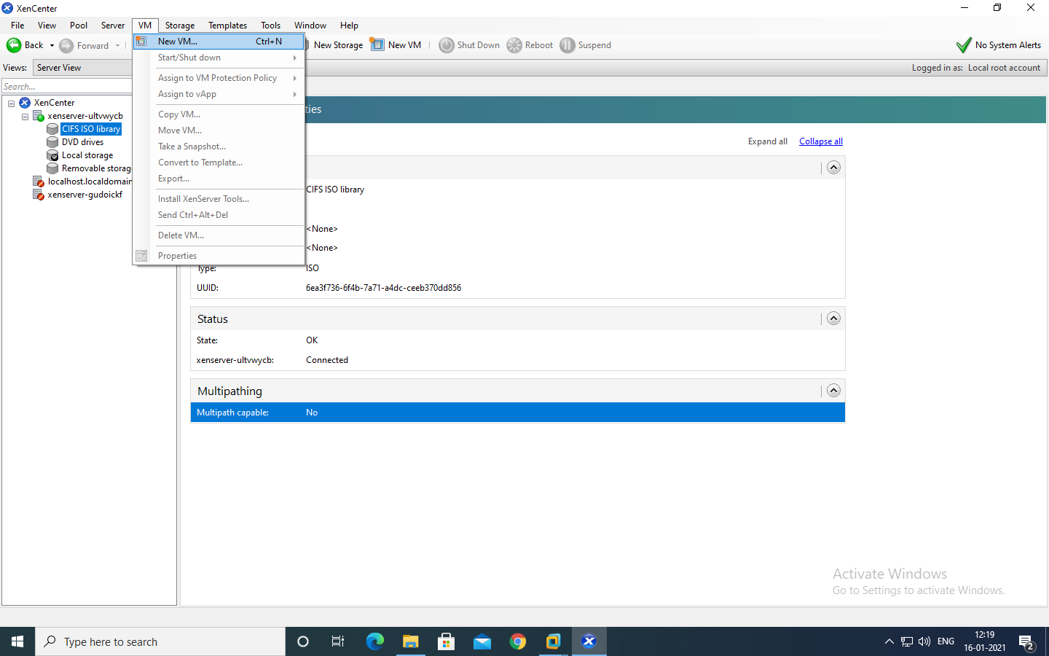

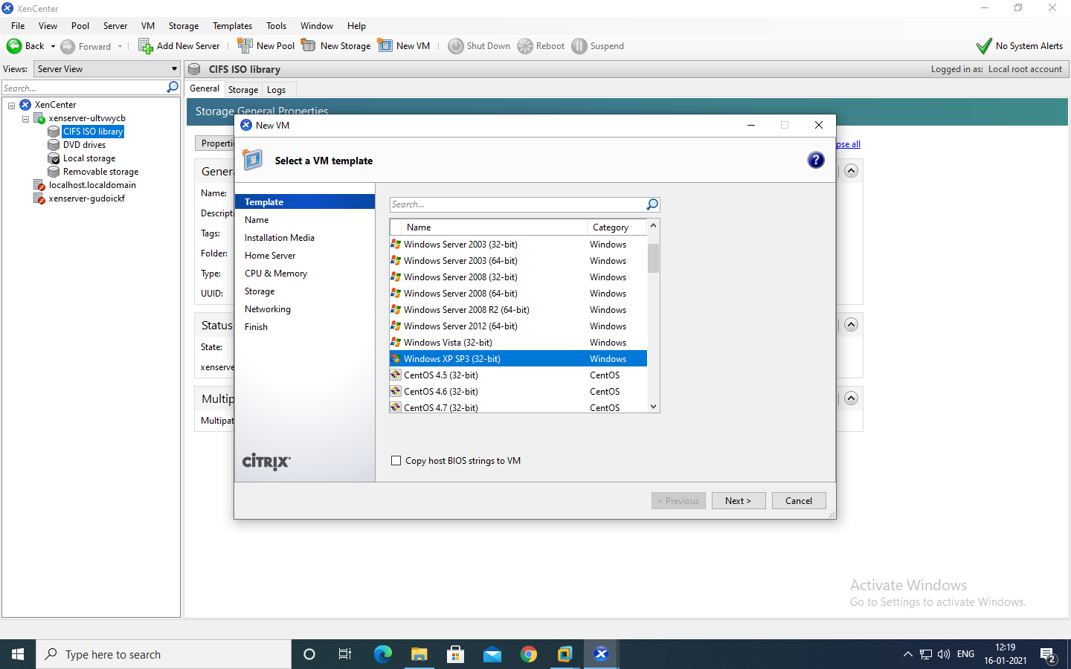

Select ISO file and click on next –

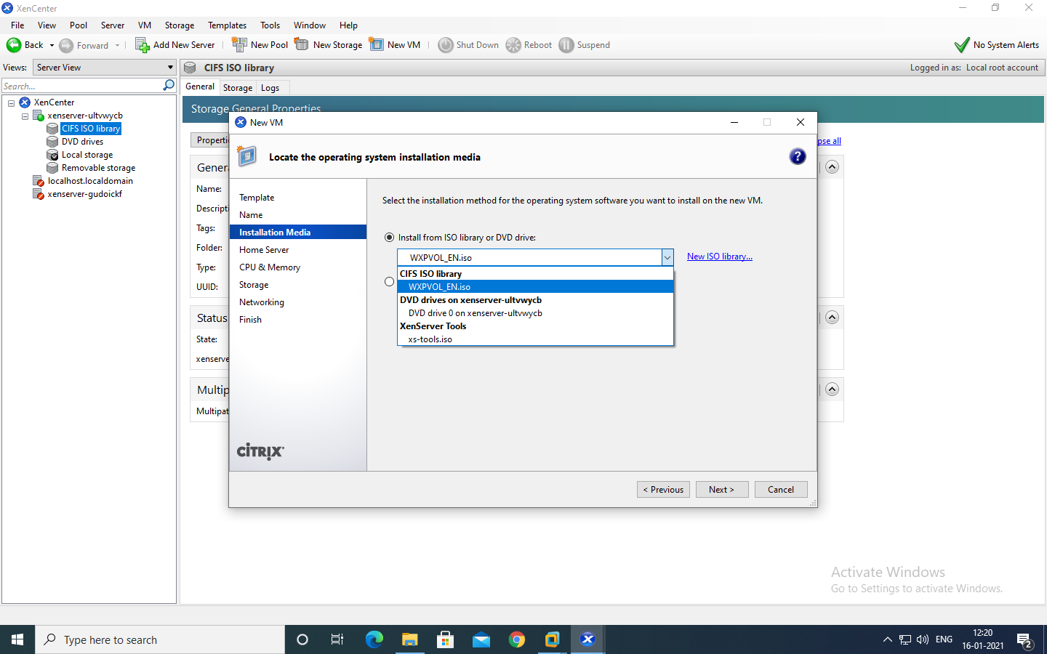

Next >> Next >> Next

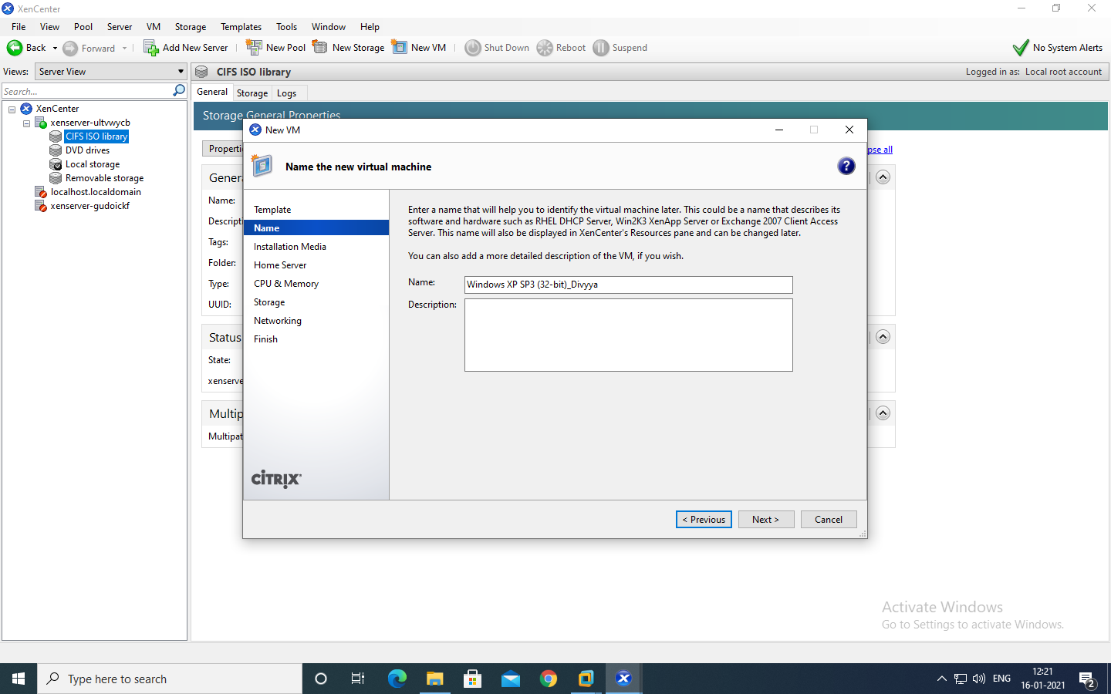

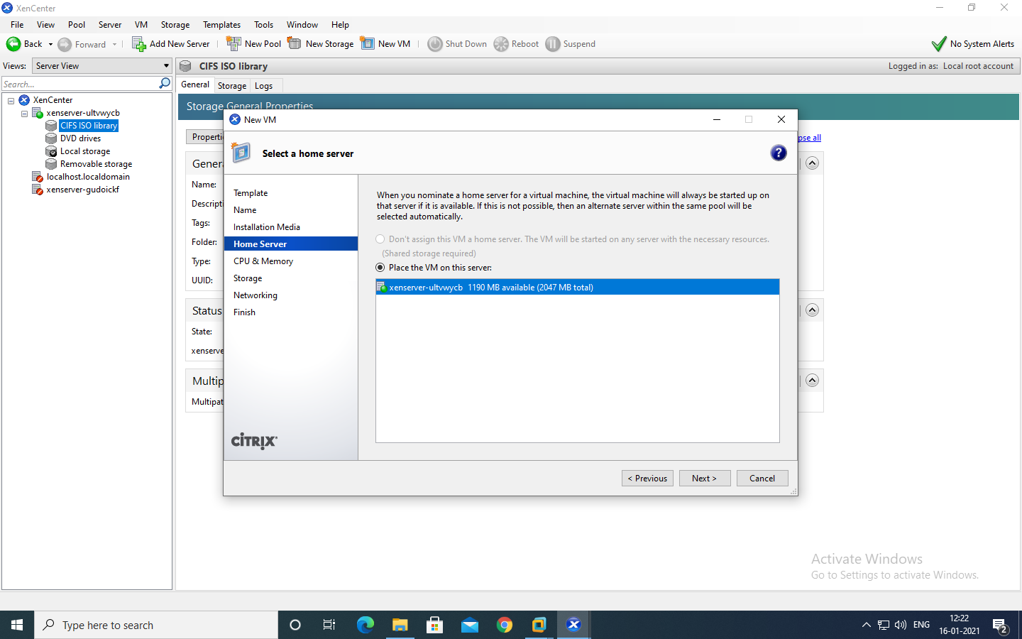

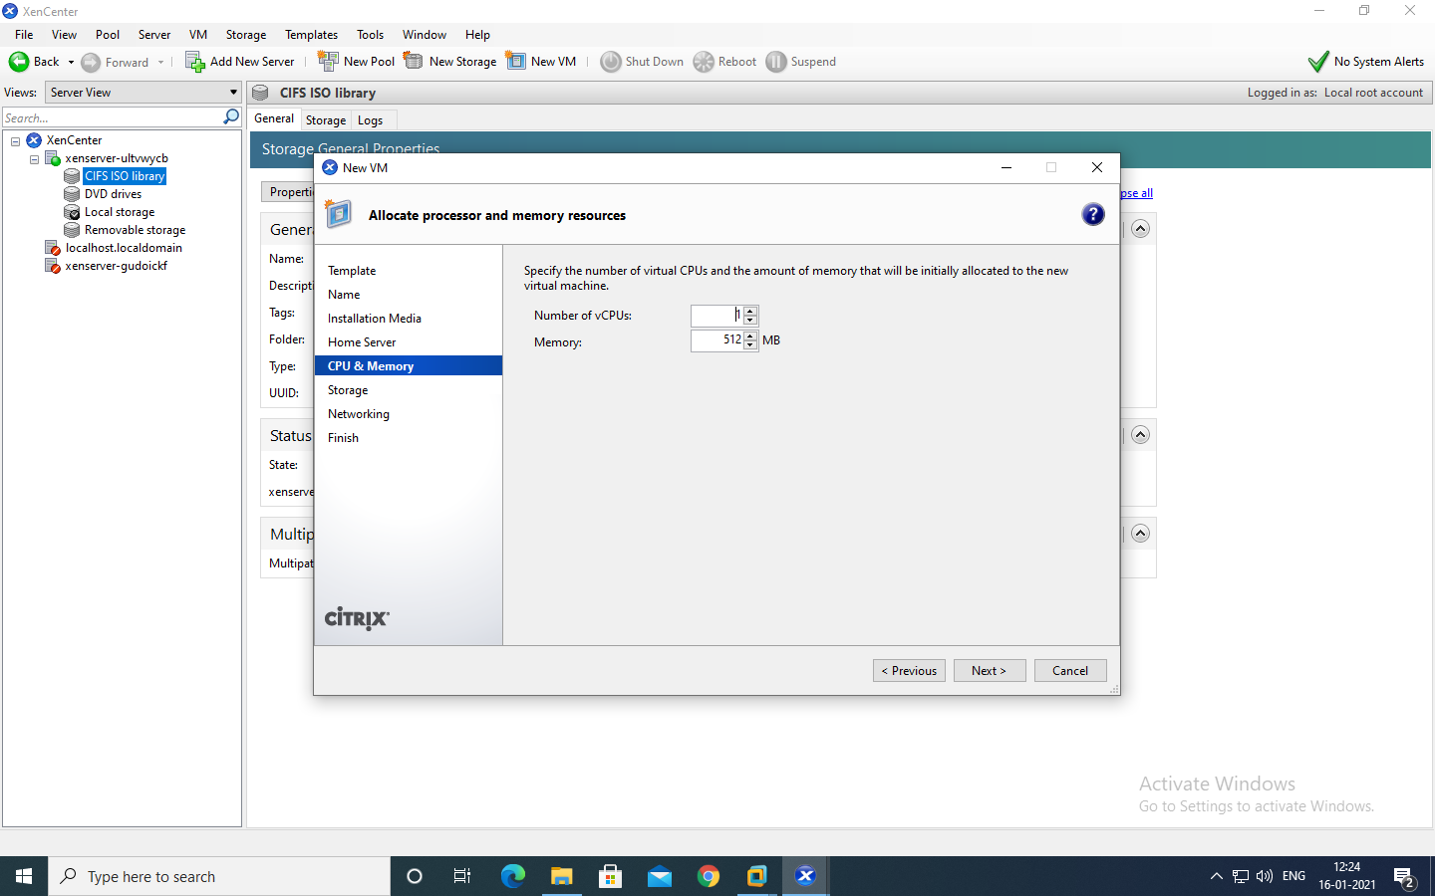

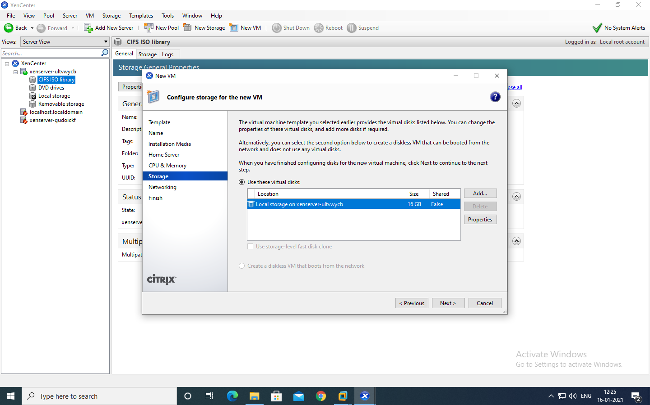

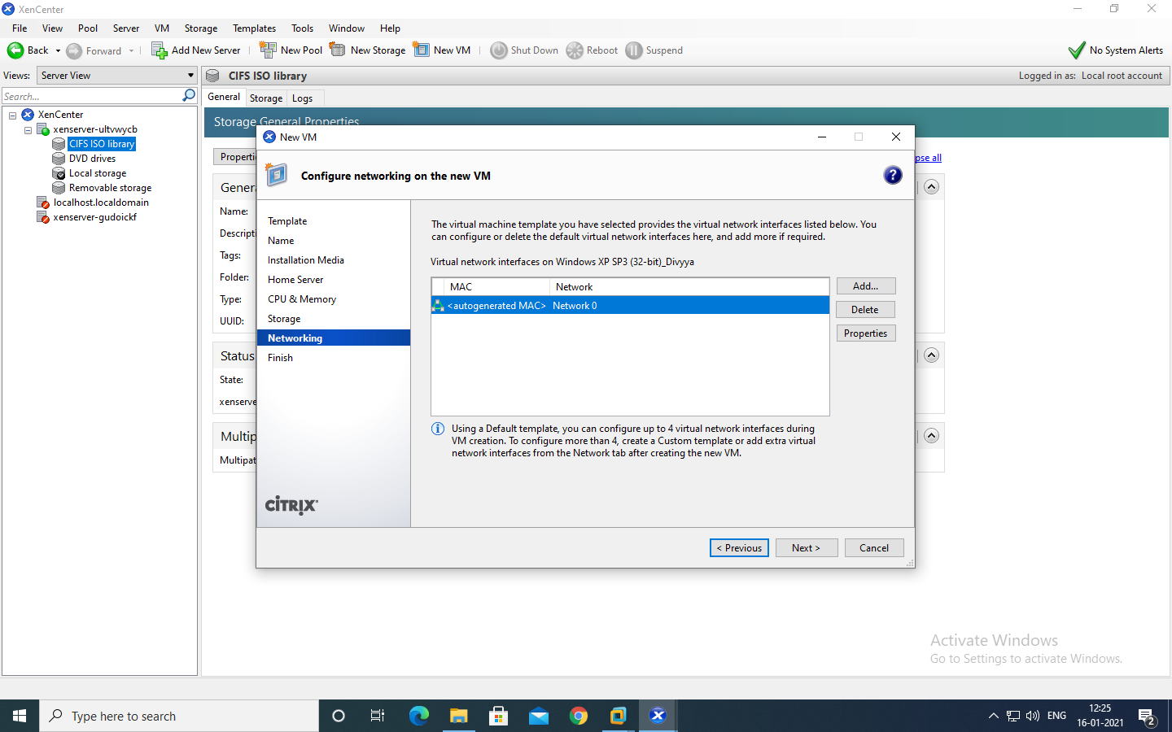

Uncheck – Start the new VM and click on create now.

